Is anyone interested in this deal?...
BUY 1 X BRICKYPEPE
…..meet the work crew of DANK CONSTRUCTION inc....
BRICKYPEPE is HOT HOT HOT!!!.... but whatever you do, dont offer her a orange juice with bits in to cool her down!...
shes into her crossfit training so you might end up in a bit of bother :-)


AND 1 X PAINTERPEPE
…….meet the work crew of DANK CONSTRUCTION inc....
would you let drunken painterpepe anywer your woodwork after a pint or 2?....
if so your braver than me!! :-)


You will receive
1 x THEWALLDANK
…..dank pepe visits the the wall and stamps his tag... as pro danks do! ;-)
danks are our education... LEAVE THOSE DANKS ALONE!!!


And
1 X THEDANKSIDE
….dank pepe originates from the dark side of the moon... obviuosly!!!
hes from the high class fidelity and drives a leeeeeear jet
MONEY!!

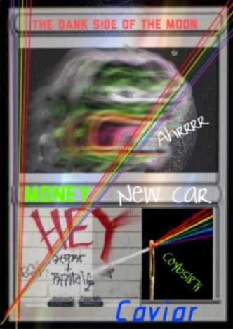

ALL FOR AROUND $40
Closing dispensers
So dm me plz

