The Vacuum Effect as Demonstrated by the Bedini Motor
Nicholas Matsukis

- Abstract:
Energy collection from the vacuum is a new emerging possibility in the field of renewable energy, as an exemplary means of increased electrical efficiency is exhibited by the concept. A simple solution to increasing battery life one hundredfold is the Bedini Motor tested and demonstrated in this paper. Building off the concepts shown offer an exciting, realistic possibility of a sustainable energy future as significantly less consumption is required in the power generation process. Thousands of data points were collected from several battery combinations using a variety of load variations, all with consistent promising results. The Bedini Motor has a profound effect upon the input battery, causing the battery to drain considerably less than predicted by modern physics. Data points were rigorously taken with careful consideration of sources for potential error. The Bedini Motor consistently operates with a Coefficient of Performance (COP) greater than one. The purpose of this paper is to present an exciting new possibility in all areas of physics to the scientific community. Background, experimental setups, and data are presented within this paper.

- Background
Inventor John Bedini was an established Audio Engineer with multiple patents. The Bedini ‘School Girl” Motor is a simple proof of concept device which claims to be demonstrating a net energy gain and electrical efficiencies over one hundred percent. Bedini devoted his life engineering the system tested in this paper, and it is the author’s goal to objectively validate or deny Bedini’s claims based on experimental results in a controlled laboratory setting. Coefficient of Performance is a ratio of output power to input power. Talks of COP>1 efficiencies are considered controversial and implausible due to a variety of constraints imposed by modern scientific literature. However, a quick review of certain literature by credible physicists in their respective fields would quickly enlighten the scientifically honest researcher.
The skepticism toward COP>1 devices is understandable as this concept violates the first two laws of thermodynamics. It is critical to understand modern thermodynamic laws only apply to closed systems, where the Bedini Motor is demonstrating an open thermodynamic concept. Many radical changes in the field of open thermodynamics have been made by Russian Chemist Ilya Prigogine. Prigogine won a Nobel Peace Prize in 1977 for his works in non-equilibrium thermodynamics, particularly with dissipative structures far from equilibrium [1]. In short, modern thermodynamics only acknowledges closed systems in equilibrium. Prigogine is important because the theoretical basis of his mechanical work is identical to the electrical effects displayed by the Bedini Motor. Prigogine proved thermodynamic systems far from equilibrium behave differently from standard systems, and open systems can exchange energy with their active environment [2]. This active exchange with the environment is essential in understanding COP>1 results, as this is precisely what the Bedini Motor is demonstrating. Prigogine himself acknowledges thermodynamics are presently incomplete, stating “the second law of thermodynamics still appears more as a program than a well-defined theory in the usual sense, as nothing precise (except the sign) is said about the entropy production. This is one of the main reasons the applications of thermodynamics is limited to equilibrium” [2]. Prigogine is stating here the second law is purely a mathematical function, as an entropic condition is forced to increase until thermodynamic equilibrium is reached. It was later shown in his Nobel Paper that thermodynamic behavior far from equilibrium is quite different from normal thermodynamic behavior. Prigogine actually showed systems far from equilibrium can behave oppositely to the theorem of minimum entropy production! [2]. Prigogine thus proved far from equilibrium systems appear disordered but create an organized state from disorder. The latter concept is electrically identical to the Bedini Motor, and reading Prigogine’s work is highly encouraged for further insights into these thermodynamic revelations.
Further, one can investigate the works of Chen Ning Yang and Tsung-Dao (T.D.) Lee for understanding vacuum symmetry in the realm of Particle Physics. Yang and Lee won the Nobel Peace Price in 1957 for The Question of Parity Conservation in Weak Interactions, in which broken symmetry in the vacuum was predicted and later proven [3]. These are revolutionary works in the field of particle physics, as this would change our understanding of Electromagnetic Energy and what exactly is causing a circuit to power. To quote the Nobelist T.D Lee, "the discoveries made in 1957 established not only right-left asymmetry, but also the asymmetry between the positive and negative signs of electric charge" [4]. It is here implied by Lee that Electromagnetic Energy is simply asymmetry within the vacuum, which is caused by a dipole or change in potential (think of the + and – in a battery). This dipole breaks the vacuum, and one can infer the source of energy is ‘pouring’ out of the dipole itself! This concept is fundamental in the Bedini Motor or any COP>1 device as a dipole needs to be established within the system in addition to the source dipole. The working principles of the dipole concept within Bedini Motor itself will be covered in the next section of this paper.

- Bedini Motor Fundamental Concepts
The Bedini Motor is a self-rotating generator motor combination. The circuit operates accordingly depending upon the position of the magnets in the self-rotating flywheel, ultimately determining the phase determining motor or generator state. Attached is a schematic of the circuit used:

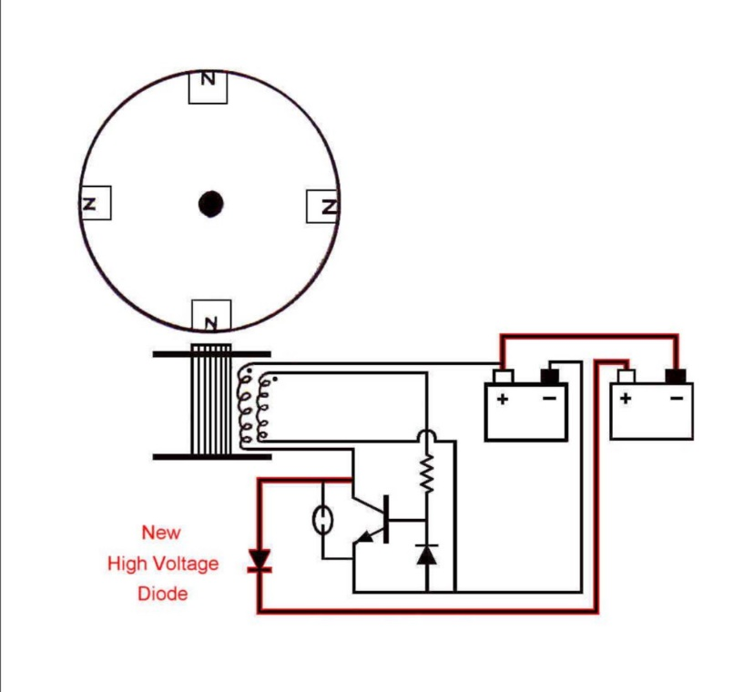

Fig. 1 – The Basic Battery Charging Schematic of the Bedini Motor

The schematic shown in Fig.1 reveals the simplicity of this device. The Bedini Motor consists of two power diodes, a resistor, a transistor, a bifilar wound coil, and the flywheel. The true purpose of the Bedini system is to keep the flywheel rotating continuously and to have a specific effect on the input battery powering this device. Upon spinning the wheel, the device will begin self-rotating. The magnets within the flywheel are attracted to the coil and will magnetize the trigger coil (the second coil not connected to the batteries) inducing a current through the circuit. As the magnet rotates past the coil, the changing magnetic flux inducing current causes the transistor to switch ON. This event causes a flow of current from the input battery into the main coil (the first coil connected to the battery). The current in the battery now forces the magnetic field induced in the coil to reverse thus its North Pole is now facing the wheel. The North Pole from the main coil magnetic field now pushes the North Pole of the magnet on the wheel away, reenforcing its established direction of rotation. This process continues until the main coil reaches its maximum point of magnetization based on the current flow from the input battery. At this instant, there is no more change of magnetic flux, thus the induced current flowing in the trigger coil loop stops. This will abruptly turn the transistor OFF consequently ceasing support of the magnetic field in the main coil, forcing the field to collapse. The collapsing magnetic field will induce a current in the trigger coil which travels a different electrical path due to the OFF-transistor state. These processes will repeat until the device is stopped or the input battery runs out of charge.
Most Engineers at this point are pleased to believe that everything occurring can be explained conventionally. However, controversy arises as the input battery loses its charge significantly slower than conventional physics explanation. Furthermore, the battery being charged seems to be gaining charge faster than the input battery is losing charge!
Upon further analysis, it is realized the batteries are being powered by a voltage transient rendered by the collapsing magnetic field. The potential induced by the collapsing magnetic field is considered to be Back Electromagnetic Force (EMF). Back EMF is introduced as a back pulse of the coils and is in phase opposition to normal EMF. Back EMF is created in this case by the changing polarities of magnets. The Bedini Motor back EMF is created by the spinning magnets inducing a transient within the system which is referred to Asymmetrical Regaugment. A flywheel with eight magnets was employed in the system tested so the flywheel is considered to be the second dipole within the system (N-Pole depending on number of magnets), in addition to the input battery. The system is demonstrating collection of disordered energy from the vacuum, which is reorganized and sent as observable energy back into the system [5]. The system at this point is considered to be open, as an active exchange with the environment is occurring, allowing for COP>1 results which will be discussed in the following sections.
It is known changing potential will induce Back EMF with no work required, therefore only magnitude change has occurred [5]. Back EMF can be considered reactive or imaginary power engineers are taught to neutralize, or ground. Reactive power can be thought of as Asymmetrical Regaugment, which is only a change in volume potential. Thus dipolarity, including scalar potential is formed from broken vacuum symmetry. Many have written theories trying to grasp the Scalar concept in serious and not serious electrical engineering literature due to occurrences previously not seen in electrodynamics. In most cases, the explanation of this effect is speculative. The Einstein-Cartan-Evans theory was developed off Yang-Mills vacuum work and attempts to provide a mathematical reference for Vacuum Scalar phenomenon [6]. Evans points out a valid starting point for Scalar theoretical physics lies hidden in E.T Whittaker’s composition of Maxwell’s equations. In short, Whittaker breaks the electric and magnetic fields into two scalar functions expanded upon by Evans. Proper vacuum adjustments were made to Maxwell’s equations by Evans, who mathematically shows functions containing a magnetic vector potential and electric scalar potential. Evan’s shows a theoretical vacuum or zero-point condition where the magnetic field is neutralized, and the electric field is a vanishing sum of two terms not equal to zero. Evans derives a scalar energy density and scalar power flux all originating from potential only [6]. His point was to show there lay hidden waves within Maxwell’s original twenty equations before being discarded by Heaviside, Lorentz, and others to simplify calculation. Evans claims to have made all of these mathematical adjustments while still following relativity laws. The present reality is that there remains several contradictions between General Relativity and Quantum Theory, and unification of these concepts was attempted and claimed a success by Evans [7].
It is emphasized that the current version of Maxwellian-Heaviside electromagnetic theory has not been 100% proven and an updated theory to explain the ever-increasing discoveries of new electrodynamic effects needs to be explored. It is also emphasized that much research and development is needed in this emerging field, and mathematical explanations presently remain speculative. This paper is merely pointing out COP>1 effects objectively exist and can be recreated in a lab setting, therefore an alternative approach to Maxwellian-Heaviside theory is needed to explain these occurrences.

- Materials and Methods
The experiment was simply using equipment to monitor battery characteristics per a specified unit of time while the device was powered. In order to ensure accurate collection of data, different means of obtaining data were employed utilizing different equipment and batteries with the general experiment remaining constant. In addition to the schematic shown in Fig.1, a variety of meters were connected to the individual batteries to accurately track Voltage, Current, and Wattage while the system was running. Current was calculated by using a standard ACS 714 Hall Effect Current Sensor attached to an Arduino Microcontroller. Two identical Arduino circuits were used and connected to each battery. The code was implemented as a means to display results to the serial monitor every one second, allowing for a simple copy and pasting of data into excel to formulate data tables and graphs. The circuit used for measuring current is shown:
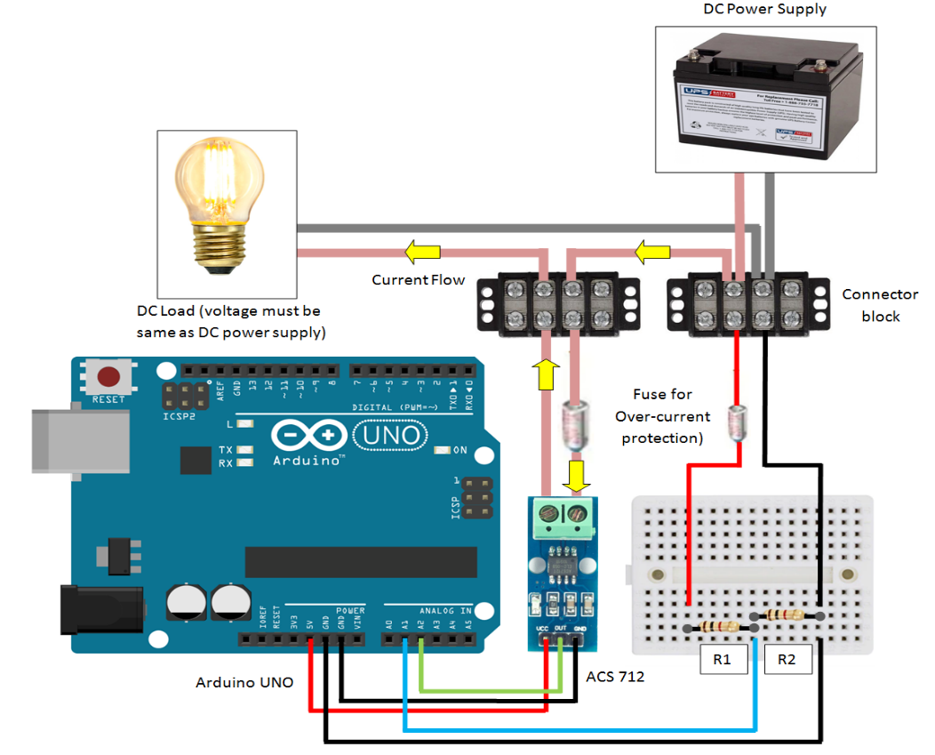

Fig.2 – Arduino Circuit for DC Current Measurement

The original intent was to use the above figure as a means of collecting all data needed for proper monitoring of the batteries. It was then discovered connecting two identical circuits of this manner to Fig.1 will short the system. To bypass this, a ground wire from R2 in the above schematic was removed on one of the devices. With the latter method, current could still be properly collected but voltage would need to be approximated with code. As a result, voltage collection was not 100% precise as was the author’s intent, so another method was employed to collect voltage data.
While the circuit in Fig.2 was collecting current, two identical OWON B35T+ Bluetooth voltmeters were simultaneously collecting voltage data. The voltmeters are conveniently designed to ensure accurate voltage data points could be graphed live while the experiment was occurring.
Further, multiple batteries of different charge and capacity were employed, all with consistent results. To ensure the effect seen is not a result of a transfer of battery capacity, the experiment was run with two identical 12V batteries of equal capacity being 5 Amp Hours. The input battery began at a voltage of 12.39V, and the output battery contained 12.36V. This was done to demonstrate the profound net energy gain seen in the system. Spinning the wheel on the system would begin the experiment, and monitoring battery characteristics while the system is running would reveal the true nature of the Bedini Motor.
The following results were formed by copying and pasting respective data values into Microsoft excel. It is known that power can be calculated by multiplying voltage and current, which is an easy excel micro. Accuracy of both meters were rigorously tested and confirmed, and careful data was compiled. The following data can therefore be considered accurate by a scientific reviewer.

- Results

Input Voltage Vs. Time
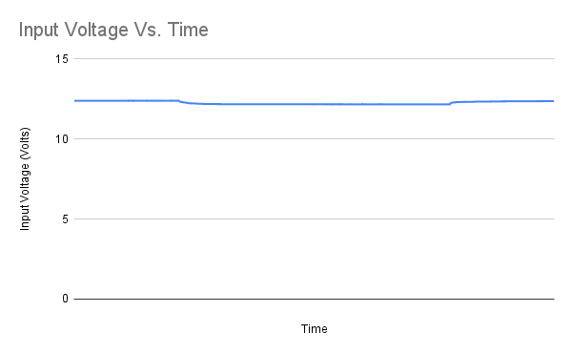
Fig. 3 – Input Voltage Vs. Time

Output Voltage Vs. Time
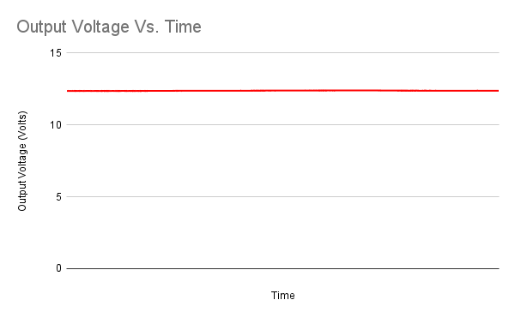
Fig. 4 – Output Voltage Vs. Time
Input Amperage Vs. Time
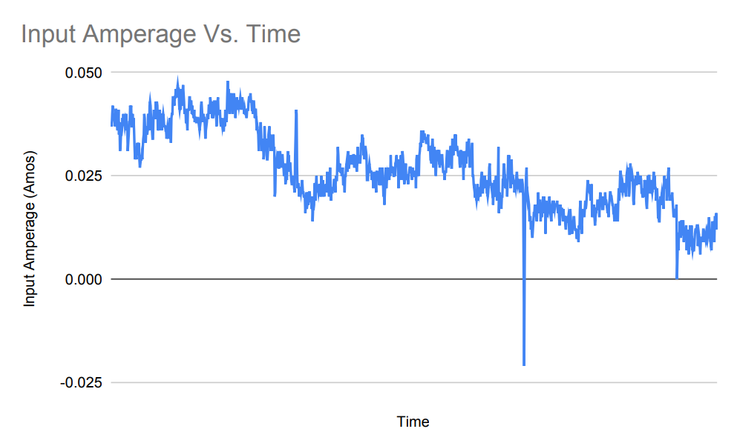
Fig. 5 – Input Amperage Vs. Time

Output Amperage Vs. Time
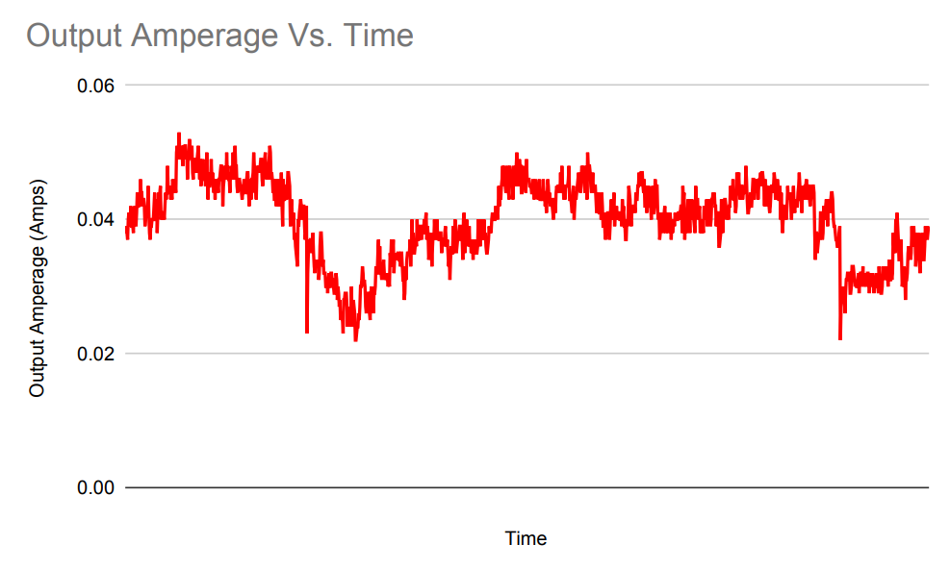

Fig. 6 – Output Amperage Vs. Time

Input and Output Amperage Vs. Time
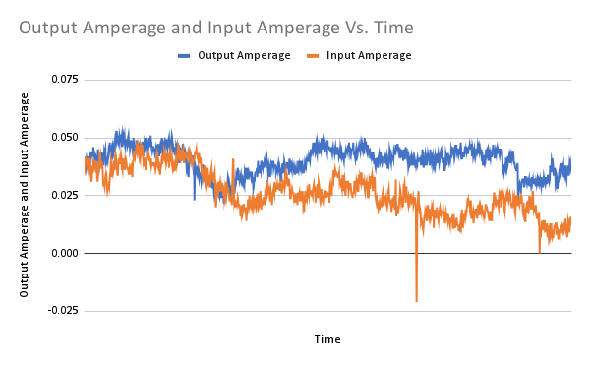
Fig. 6.5 – Output and Input Amperage Vs. Time
Output and Input Power Vs. Time
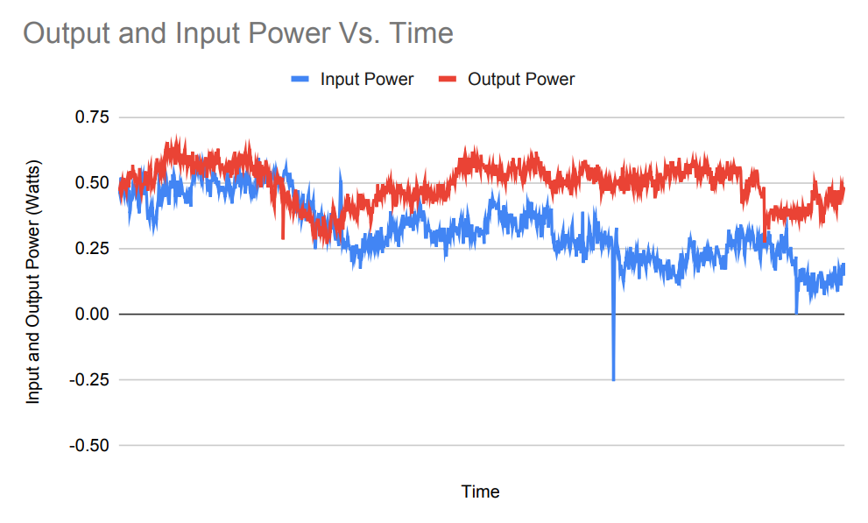

Fig. 7 – Output and Input Power Vs. Time

COP Vs. Time
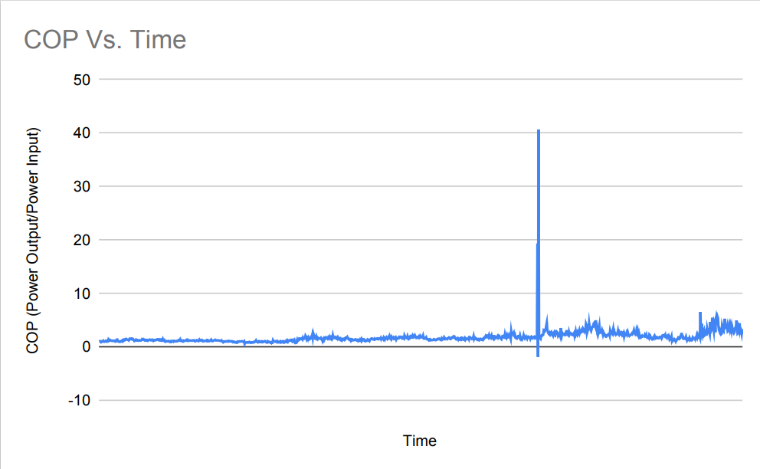
Fig. 8 – COP Vs. Time (The stray data points at 40 and <0 are written off due to error)

Input and Output Watt-Hours Vs. Time
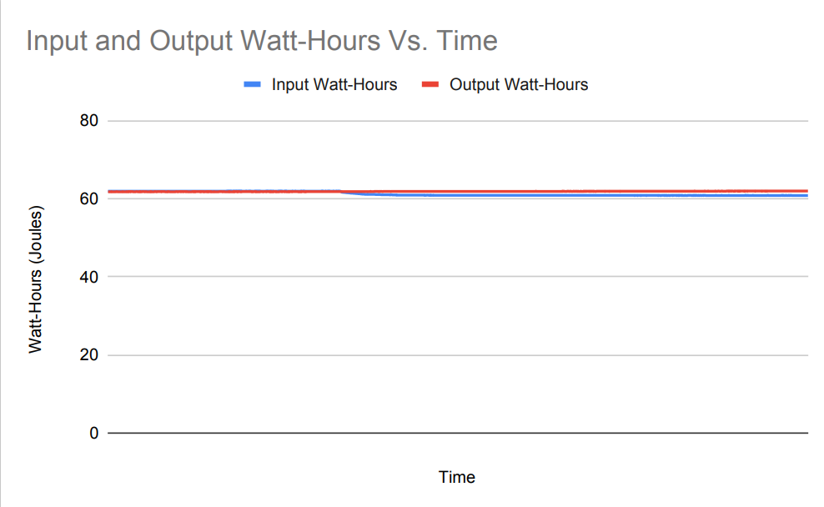
Fig. 9 – Input and Output Watt-Hours Vs. Time

- Discussion
Many interesting conclusions can be formed when analyzing the graphical results collected from this short period of time (20 minutes). COP Vs. Time specifically should be noted, as every instance Fig.8 is above one is a state of over-unity, the sole purpose of this demonstration and device. Observing the graph shows prior to turning the wheel on the device, COP remained less than one. Upon powering the device, the Input Voltage immediately decreased to around 12.20V for the remaining duration of the wheel spinning. Output voltage increased at a slow linear rate. It should be noted output voltage typically increases significantly more; the device was not working at its full capacity during this specific data set. Fig.8 reveals the effect seen in the batteries appear to be more profound with time. Additionally, Input and Output Amperage Vs. Time seems to be of utmost importance. Fig 6.5 reveals initially both batteries begin with identical amperage draw, at approximately 0.040 Amps. Spinning the wheel significantly decreases amperage draw in the input battery while simultaneously remaining constant in the output battery! This would leave one to conclude that the COP>1 effect in this case occur as a result of the shift in amperage within the battery input. The system seems to create an effect where Input Amperage draw decreases when the wheel is spinning at maximum rotations per minute. It is seen from the latter that there must be an external active vacuum environment assisting in power generation of the system as the device recovers energy faster than what is lost. The system further appears to increase in efficiency the longer the wheel spins, as a slight linear increase is noted on the COP Vs. Time graph. It is also interesting to note that upon stopping the wheel and depowering the system, most Input Voltage lost within the system seems to be reclaimed by the input battery! A clear increase in Input Voltage is observed when referring to Fig. 3 and concluded to be the moment the device is depowered. Others who have experimented with this system and Bedini himself have speculated the batteries are powered with voltage spikes containing little amperage. The author cannot currently confirm nor deny this, as further investigation is required to comprehend the cause of decreasing Input Amperage upon powering the system. It is therefore concluded in this paper is there is an active vacuum environment partially assisting the device in power generation, causing an increase in efficiency not from the input battery or any external power sources.
- Conclusion
It is concluded system design in consideration of the active vacuum environment will significantly lead to greater electrical efficiencies in machinery not seen presently. The mathematical effect of the vacuum phenomenon still remains mostly speculative. A coherent unified field theory proved to be explaining Maxwell’s equations in a vacuum would be Nobel Prize worthy. However, it remains certain from this demonstration the feasibility of COP>1 open systems. The effect causing this increase in efficiency appears to occur within the input battery amperage, as amperage draw decreases significantly upon starting the device. The escaped input voltage also appears to be recaptured in the input battery, as the final ending voltage was 12.38V, compared to an initial 12.39V starting within the battery. It is of utmost importance for the reader to understand COP>1 machines will end the energy crises, as engineering a self-sustaining system is a realistic possibility with the concepts demonstrated in this paper. It is presently apparent much is not understood about these concepts and more research and funding is needed. Funding and promotion of this research is essential in creating a sustainable future for humanity as COP>1 devices will tremendously help obfuscate human consumption and end the scarcity mindset.

Works Cited
[1]. About CQS (2021) The Center for Complex Quantum Systems. Available at: https://sites.utexas.edu/order/2021/05/03/shy-longhorn/#:~:text=Ilya%20Prigogine%20was%20awarded%20the,Russia%20on%20January%2025%2C%201917 (Accessed: 26 May 2023).

[2]. Prigogine, I. (1978) ‘Time, Structure, and Fluctuations’, Science, 201(4358), pp. 777–785. doi:10.1126/science.201.4358.777.

[3]. Tsung-Dao Lee – Facts. NobelPrize.org. Nobel Prize Outreach AB 2023. Sat. 27 May 2023. https://www.nobelprize.org/prizes/physics/1957/lee/facts/
[4]. T. D. Lee, Particle Physics and Introduction to Field Theory, Harwood Academy Publishers, Chur, New York, and London, 1981, p. 184
[5]. Kerimov, O.Z., Tabatabaei, N.M. and Rahmanov , N.R. (2015) ‘MAGNETIC DC MOTOR WITH PARTIALLY SUPPLIED BY ENERGY FROM VACUUM’, International Journal on “Technical and Physical Problems of Engineering”, 7(24), pp. 32–36.
[6]. M.W. Evans et al., “Generally Covariant Unified Field Theory” (Abramis, Suffolk, 2005 onwards), vol 1-7
[7]. H Eckardt, D.W. Lindstrom, “Solution of the Evans-Cartan-Einstein vacuum equations” , in “Generally Covariant Unified Field Theory”, vol 7 (Abramis, Suffolk,2011), pp.207-227

